Tcp/ip

4. AP mail/data 🡪 data

TCP 1 | mail | data

3. TRV …… 🡪 segment

TCP 2 | mail | data

SIP | DIP | TCP 1 | mail | data

2. INTV 🡪 packet

1. V.P.D.S 🡪 ramce

S MAC | D MAC | D IP | S IP | TCP 1 | mail |data

ISO OSI

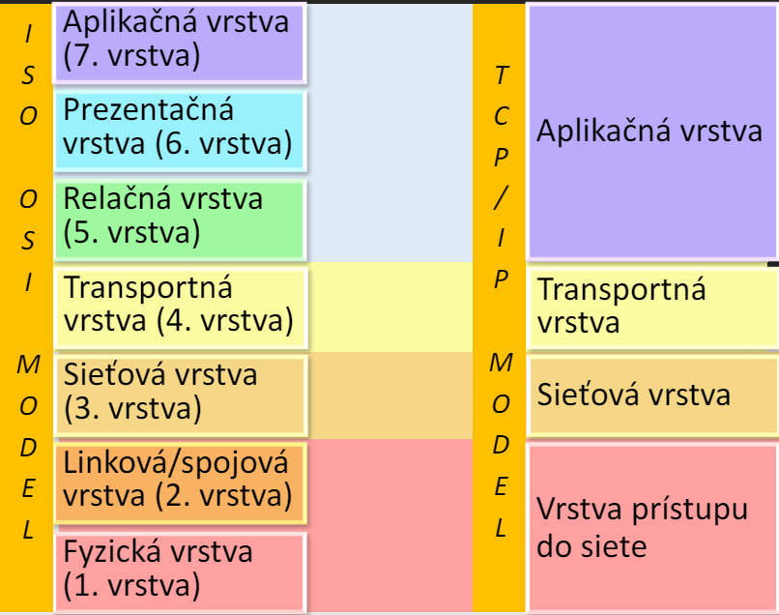

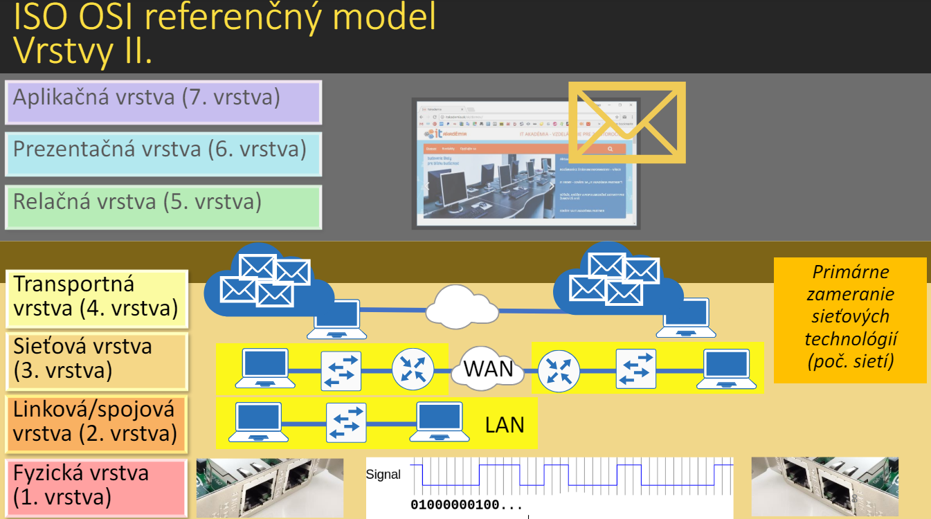

Pc1 -- switch -- PC2

Pc1 -- switch -- router -- pc2

IP S | IP D | MAC S | MAC D   
PC1 | PC3 | pc1 | router

Na routery to bude:

IP S | IP D | MAC S | MAC D   
 PC1 | PC3 | router | pc3